**Innovative Public Transport Optimization**

Designing a innovative Public Transport Optimization Project incolves several key steps:

1.Needs Assessment and Goal Setting:

.Identify the specific needs and challenges of the public transport optimization.

.Set clear goals,such as reducing waiting times,increasing ridership or minimizing environmental impact.

2.IoT Infrastructure Planning:

Determine the necessary IoT sensors and devices, considering factors like GPS, passenger counters, cameras, and environmental sensors.

Plan the communication network to transmit data from these devices.

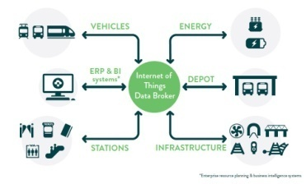

3.Data Collection and Analytics:

Collect data from IoT sensors and vehicles in real time.

Use advanced analytics and machine learning to derive actionable insights.

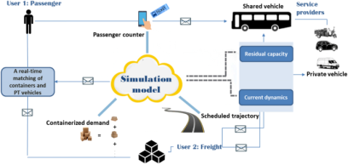

4.Route Optimization:

Develop algorithms that optimize bus/train routes in real-time based on passenger demand and traffic conditions.

Consider dynamic routing adjustments to avoid congestion.

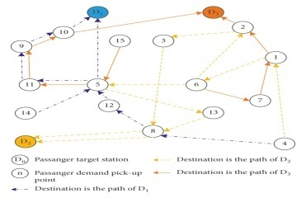

5.Smart Ticketing and Payment Systems:

Implement innovative ticketing solutions like contactless payments, mobile apps, or subscription models.Integrate payment systems with the broader public transport network.

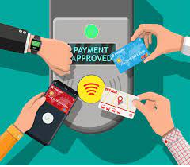

6.Passenger Experience Enhancement:

Design smart stations with digital displays for real-time information, ticket kiosks, and comfortable waiting areas.Consider interactive information apps for passengers.

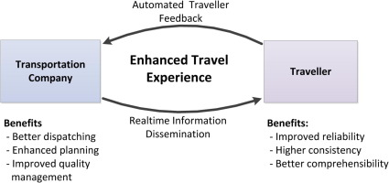

7.Predictive Maintenance:

Use IoT data to predict maintenance needs and schedule service before breakdowns occur.

Optimize maintenance routes to reduce downtime.

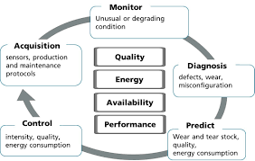

8.Environmental Impact Reduction:

Implement eco-friendly initiatives like electric or hybrid buses, and monitor their performance.

Use IoT to track and reduce emissions.

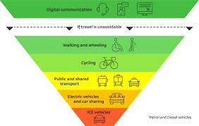

9.Security and Safety:

Incorporate IoT-based security systems such as surveillance cameras and emergency buttons.

Establish protocols for responding to safety incidents.

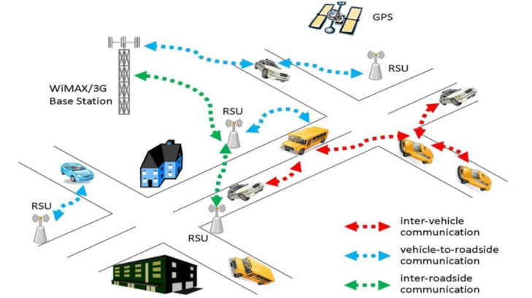

10.Public Engagement:

Involve the public in the design process through surveys and feedback mechanisms.

Educate passengers about the benefits of the IoT-based system.

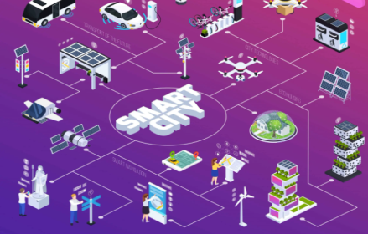

11.Regulatory Compliance:

Ensure that the project complies with relevant transportation regulations and data privacy laws.

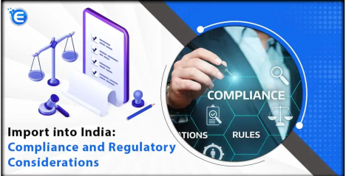

12.Pilot Testing:

Conduct small-scale pilot tests to identify and address any issues before a full-scale implementation.

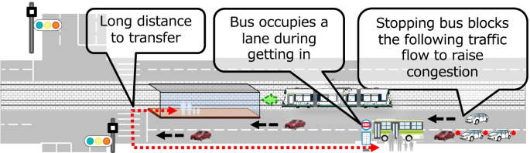

13.Scaling Up:

Gradually implement the IoT enhancements across the entire public transport network.

14.Continuous Improvement:

Regularly evaluate and improve the system based on data and user feedback.Adapt to emerging technologies and changing passenger needs.Innovative public transport optimization involves a holistic approach that combines IoT technology with a focus on improving the passenger experience, efficiency, and sustainability.

Project Submitted by,

Name : G.Bhuvin Buthanil Vells

College Code : 7139

NM id : au713921106004

Mail id : gphuvin@gmail.com

Topic : Public Transport Optimization Innovation